

**Topic: Loan Management Database System**

**Student Name: Santhi Kiran Chavali**

**Course name: ITC 6000 Database Management systems**

**Institution Name: Northeastern University**

**Instructor’s Name: Na Yu**

**Introduction**

A Bank is a financial institution that provides various types of services to its customers. Banks have to deal with various tasks like Walk-in customers, Account openings, Deposits, Transactions, Safety lockers, Various types of Loans, advances, Transfer of funds, etc. and generating reports for every transaction taking place and preserving them.

For this project, I have limited the scope to Loans. The Loan Management Database system is a digital platform that includes all the loan processes from applying for a loan to the Closure of the loan. It provides good communication between customers and the Branch. This system is user-friendly which means it is easy to understand and customers can apply for a loan from anywhere by login into the bank’s website or using a mobile banking application. It reduces calculation errors. It identifies the High-risk customers and reduces the risk of bad debts, It enhances customer service, Better document management and it requires only minimum paperwork.

The main reason for choosing this topic as my final project is I have worked in a bank for 8 years in India so I have good knowledge about how a bank works, what are the services available, and the problems faced by the customers as well as staff in a bank. From my experience, I have observed that customers face a lot of problems while taking a loan and the pressure staff has while doing the background verification in the process of giving a loan and the time to sanction a loan.

**Use cases**

It basically represents how the tasks will be performed by the users of the system. Use cases for the Loan management database system are:

1. Customer has to register with the Bank and bank will provide them with unique login credentials.
2. Customer has to login to the bank website using the login userID and password
3. Upon successful login, Customers can view different type types available in the website and they can choose what type of loan and loan amount they require.
4. customers have to update additional details like Professional details, income, and securities they are willing to offer.
5. After filling in all the details customer can submit the loan application. Upon successful submission, they will receive an SMS and an e-mail confirming the same.
6. Other the other hand once the loan is submitted by the customer, A loan officer will be assigned to them and they will interact with customers directly regarding the loan and obtain further details if required.
7. Customers can check the loan status by login to the website with credentials provided to them

**Business Challenges**

1. **Manual handling of the lending process:**

Existing lending involves more manual work which is difficult and expensive as well as it requires customers to visit the branch every time and even branch officials have to conduct verification manually. it also involves a lot of paperwork

1. **Dissatisfied customers:**

Customers are getting disappointed due to the lengthy procedures of the existing loan system and the time taken for the loan to get sanctioned especially when they required funds immediately.

1. **Delay in Loan sanctions:**

Once the loan proposal has been received at the branch. The staff has to go through a lot of back-end verification processes like ID and Address verification, income verification, generation of credit information reports, inspecting securities, etc. because of the enormous volume of loan applications and limited staff, sanctioning the loans takes a lot of time.

1. **Identification of bad debts and defaulters:**

With the lack of risk estimation tools and unable to generate the required reports in the existing system, It is hard to identify the bad debts and defaulters.

**End Users/Personas**

Basically, we have Two types of personas for this Database System One is Admin, and the Other is a different type of customer.

**Admin:**

* On the admin side we have Branch In charge, and Loan officers. Each of them will be provided with unique login credentials through which they can access the database. Admin staff can check the total applications received, the Status of the loans, details of repayments, and monitor the transactions. They can also make modifications if necessary and update the loan details.

**Customers:**

* On the customer side we have various types of Customers:

**Students:**

* Students can use this system for applying for Education Loans, once students have registered with the bank and logged in with the credentials provided. They have to enter additional details like the Loan amount required, proposed college or university’s offer letter, fee structure, existing grade reports, etc. and collateral securities offered if any like parent’s immovable securities.

**Individuals:**

* Once customers have logged in to the system there will be several types of loans they can apply for based on their requirements. Few of the consumer loans that are available are:
* Vehicle Loans: To purchase Brand new vehicles or pre-owned vehicles.
* Personal Loans: Loans against their income to fulfill their personal needs and requirements
* Housing Loans: To purchase a house or to construct a house
* Mortgage Loans: Loans against existing properties like houses or open plots.
* Agriculture loans: Crop-based loans to farmers.

For all of the above loans, customers need to add additional details while applying for the loan like the Loan amount required, Professional details, Income details, and collateral securities offered based on the type of loan they want to avail

* **Corporates**

Corporates require loans to run their business, Types of loans corporates can apply for are overdraft facilities, corporate vehicle loans, bank guarantees, etc. Here the authorized signatories will log in to the system and apply for loans in the name of the company or organization. They are required to provide the company’s registration documents, balance sheets, profit/loss statements, securities offered, stocks, and debentures.

**Business Rules**

* **Customers:**

1. Customers have to create an account and register with the bank. Bank will provide unique Login credentials.
2. Customer has to login to the website using the credential provided by the bank
3. After successfully logging in, customers can view different types of loans available.
4. Customers have to choose a type of loan based on their requirements.
5. Once a type of loan is selected, they have to update more personal information like contact details, email id, address, etc., and based on the loan type they are asked for additional information like loan amount required, professional details, income details, securities offered, Bank statements, Income tax returns, Balance sheets, etc.
6. Once all the details are filled in customers can submit the loan application
7. Up on successful submission of the loan application, SMS and a mail will be sent to the customer’s registered contact number and email id.
8. Customers can view their loan status by logging in with provided user id and password.

* **Admin:**

1. On the Admin side, Branch In charge and loan officers can log in to the system using their unique credentials.
2. On successful login they are given access to check existing loan applications New loan applications received, status of different loans, repyments,etc. They are allowed to make modification to the loan proposals and manage customer profiles.
3. A Bank employee from the loan department will be assigned to each customer.
4. Employee will go through the personal and professional details of the customer
5. Generates Credit report to find out the past credit details of the customer.
6. Based on the Credit report, Income details, Net Take Home, Collateral Security offered, and existing limits, the Employee will decide whether to sanction the loan or reject the loan
7. Once all the background verification is done and is satisfactory to the bank. The loan will be sanctioned and the customer will receive the message and mail regarding the same. And, the loan amount will be disbursed once the loan agreement is signed by the customer and countersigned by the Loan officer
8. After disbursement employee will be monitoring the repayments and will be collecting a penalty amount for late repayment.

**Tables design and analysis**

**This Database system has Five tables:**

1. **Branch (Branch_ID(PK), Name, Location)**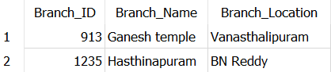
2. **Loan Officer (Officer_ID(PK), Name, Deignation, branch(FK))**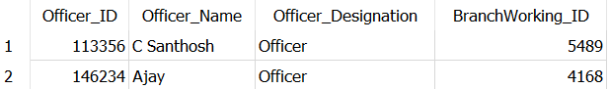
3. **Customer (Customer_ID(PK), Name, DOB, email, Income, credit score, contact no, branch(FK), loan ID(FK))**



1. **Loan_Repayment_Info (Transaction_ID(PK), Date, amount, Cust_ID(FK))**

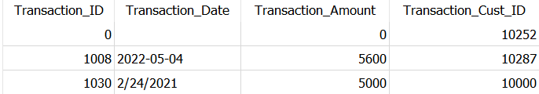

1. **Loan_Information (Loan_ID(PK), loan type, loan repayment in months, Rate of Interest, Collateral type, Collateral amount, Loan_Cust ID(FK))**



**ERD Diagram**

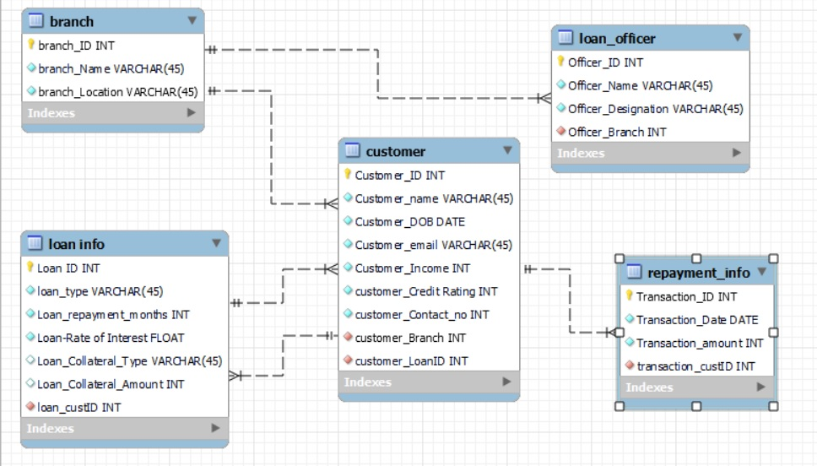

**Database Implementation examples**

**Example 1: SQL Query to know the number of customers availed from the bank listed branch wise**

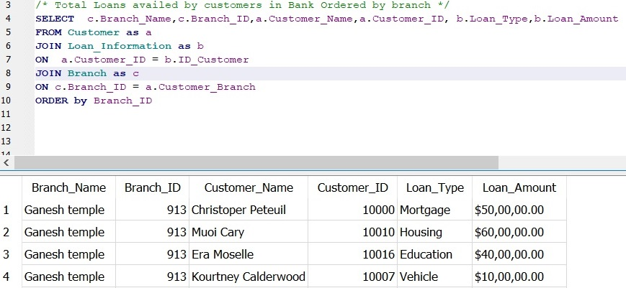

**Example 2: SQL Query to get details of Total loans availed by the customer ID “10000” and amount repaid**

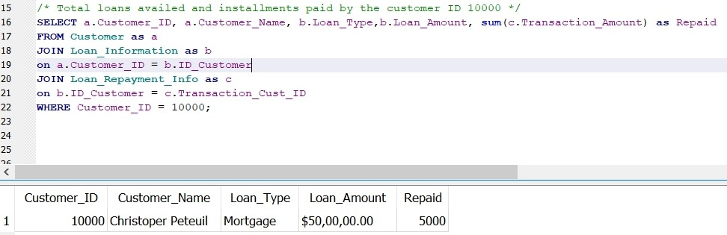

**Example 3: SQL Query to know the Number of education loans given by Branch with ID “913”.**

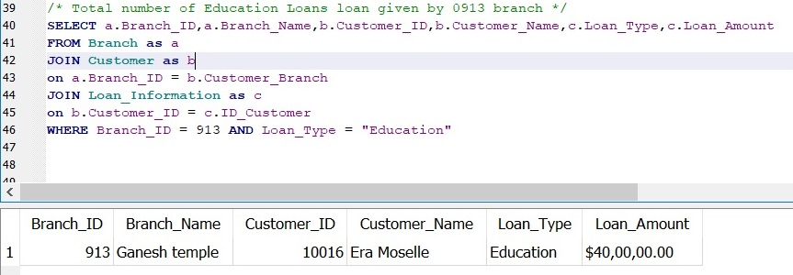

**Example 4: SQL Query to create New table with total loan amount availed by the customer and total amount repaid**

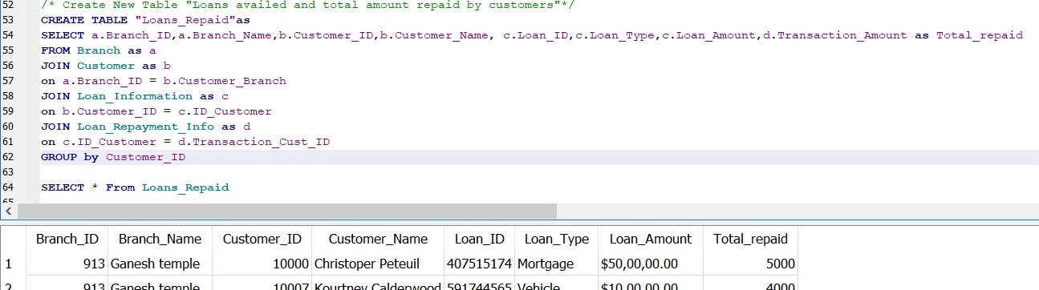

**Example 5: SQL Query to know the number of staff handling loans in Branch with ID “5489”.**

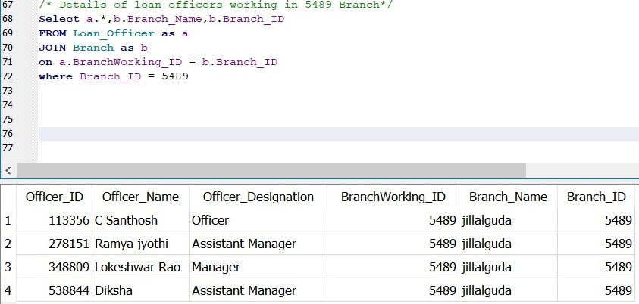

**Metrics and Analytics**

**Branch:**

-- Number of Branches under a bank

-- Number of branches where Loans applied

**Admin:**

-- Number of staff working in a branch

-- Number of Loans sanctioned by each staff

-- Status of loans under each staff

**Customer:**

-- Number of customers

-- Number of Loans availed by a customer

-- Number of branches where a loan is availed by each customer

**Loans:**

-- Number of loans

-- Type of Loans

-- Number of loans pending, rejected and sanctioned

-- Number of loans where payment is regular/ irregular

**Security and Privacy Concerns**

* Loan Management system is vulnerable to many attacks.
* It contains confidential information like customer’s personal, professional, bank account, cards, property details, etc.
* It often possesses threats by hackers and terrorist organizations to access these details.
* To overcome these, the following security measures should be taken care of security teams:

1. Installation of effective security systems.
2. multiple authentications for accessing the database,
3. Database monitoring and audit

**Database Architecture**

* This database follows Client – Server Architecture where several customers will be accessing the server which contains all the information about various types of loans
* This system is available on the website and as well as a mobile application.
* This database system requires a minimum of 50 Terabytes of memory as it stores a lot of customers’ information and as well as there will be requirements for a different type of loans for customers.
* Example of Architecture diagram:

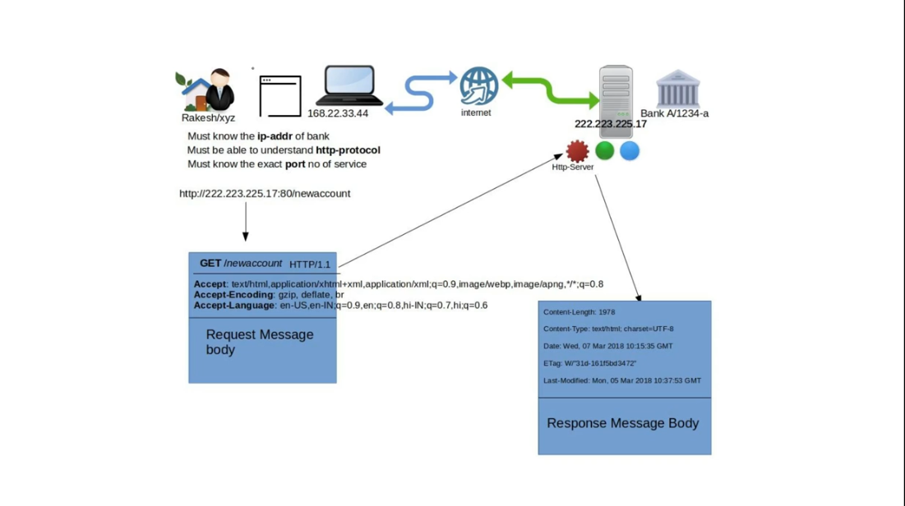

**Reference:**

Kannaujiya, S. (2018, October 31). Understand Client-server architecture by real life example. Medium. <https://medium.com/@satyendra250896/understand-client-server-architecture-by-real-life-example-f1a239577099>

**Next Steps and Lessons learned**

**Lessons Learned:**

This Project helped me to learn Basic to Advanced SQL commands.

Different types of joins and their use.

Creating ERD Diagrams

Implementing crow foot notation.

Different types of keys like Primary Key, Foreign Key, etc.

Creating a Database

**Next Steps:**

I would like to add some more features and make it easy for users.

I would like to use this knowledge in future coming projects, learn more skills, and do more complex projects.